

Fanuc Robodrill VMC Machine
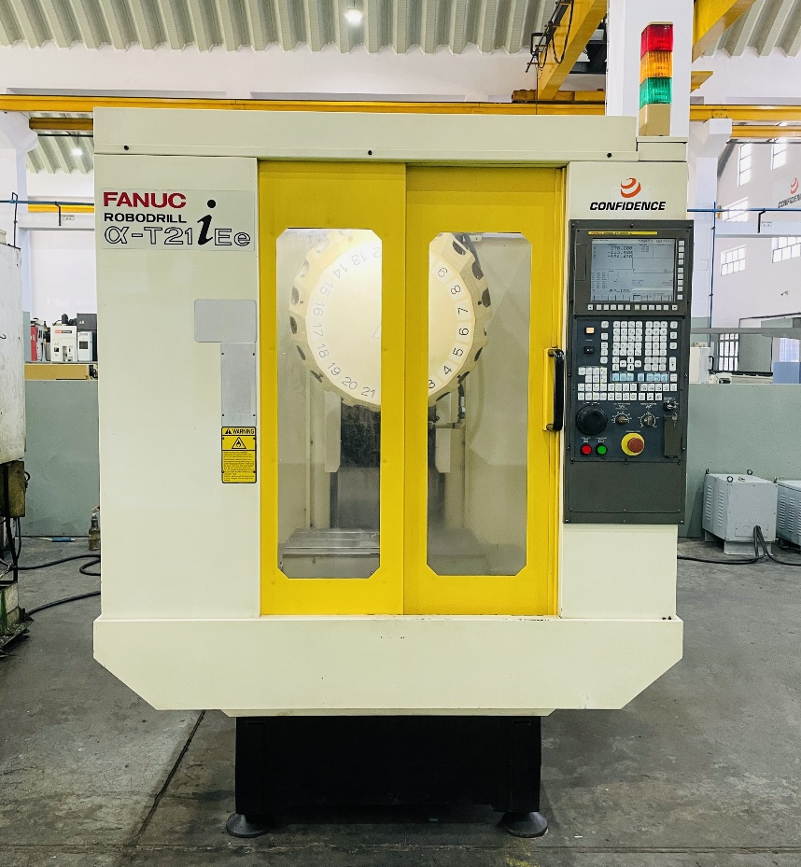
MODEL: - α-T21iEe, YOM: - 2005

- Optional Accessories Available with Machine
- 24000rpm BT30 Spindle  - 21 tool ATC  - FANUC 31i-MA Controller | - Leveling Pad
Title | Description | Unit | α-T21iEe
Travel | X- axis | mm | 500
Travel | Y- axis | mm | 400
Travel | Z- axis | mm | 330
Spindle | Spindle nose | type | BT30
Spindle | Spindle speed | rpm | 24,000
Spindle | Spindle Power | Kw | 5.5/3.7
Table | Table Dimensions | mm | 650x400
Table | Max. Loading Weight | Kg | 300
ATC | No. of Tools | Nos | 21
Feed rate | Rapid Traverse of X, Y, Z axis | m/min | 48 x 48 x 48
CNC System | Controller | - | Fanuc 31i-MA
Machine size | Dimensions (L x W x H) (Approx.) | mm | 1600 x 2100 x 2350
Machine size | Machine weight (Approx.) | kg | 2200

